Accessibility Guide for the Station Agent’s House

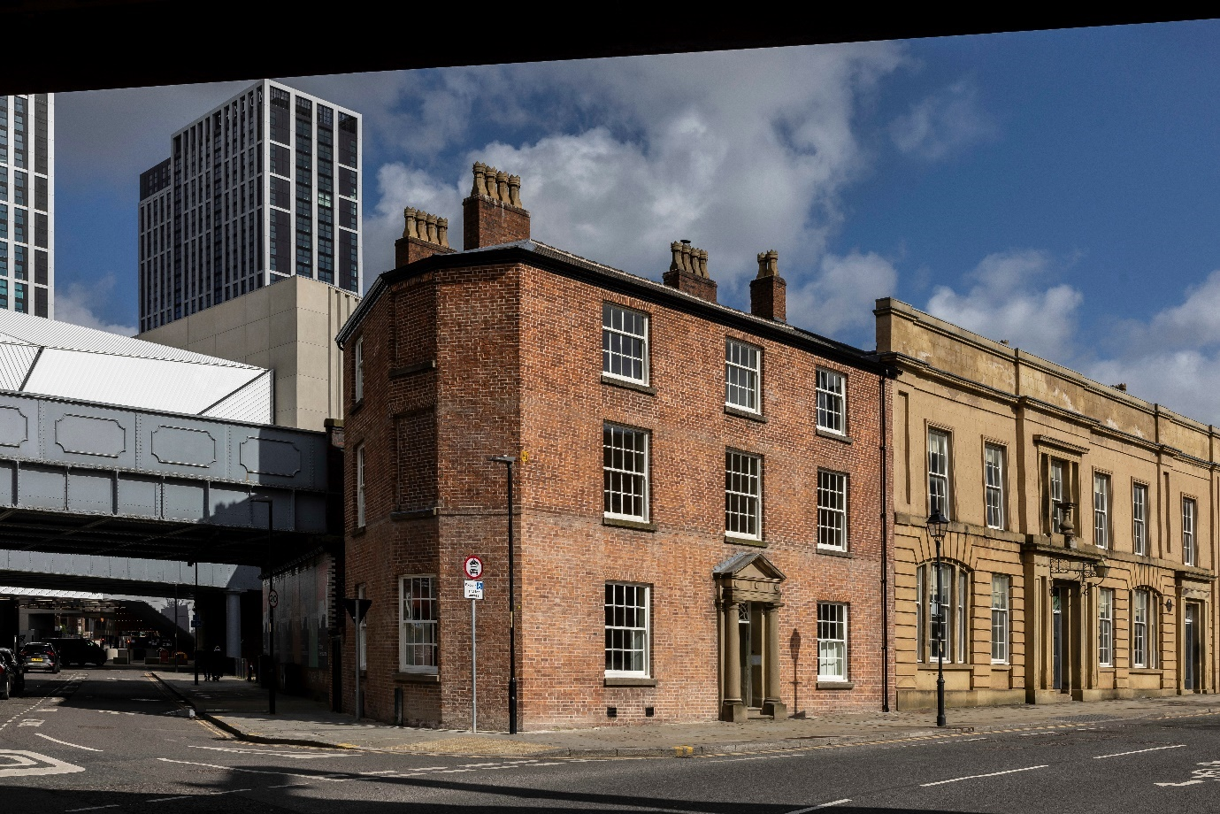

At the dawn of the Railway Age in 1830, Liverpool Road Station opened as the world’s first purpose-built, inter-city passenger railway terminus. The home of its Station Agent has become environmentally sustainable and accessible holiday accommodation in the heart of Manchester.

The Station Agent’s House is fitted with a selection of mobility, hearing and visual facilities. The purpose of this document is to describe those facilities.

# Contents

Accessibility Guide for the Station Agent’s House 1

Contents 2

Contact us 2

Introducing the Station Agent’s House 3

Getting here 4

Arrival 5

Getting around inside 7

Customer care support 15

# Contact us

For all enquiries, including any related to accessibility requirements, please contact our Booking Enquiries team on:

* Email: [booking@landmarktrust.org.uk](mailto:booking@landmarktrust.org.uk)
* Phone: 01628 825925
* Fax: 08432 906896

If you require the accessible handrails and shower seat for the ground-floor shower room, together with the accessible handrail for the first-floor toilet, as described and pictured below, please contact us at least seven days prior to your arrival date.

# Introducing the Station Agent’s House

At a glance

### Wheelchair icon Level access

There is level access from the rear entrance into a cloakroom space.

Situated in the cloakroom is a platform lift, providing access to the ground floor.

On the ground floor there is level access to:

* Two accessible bedrooms, being one twin and one double
* Accessible showroom

Also situated on the ground floor is a passenger lift, providing access to the first floor.

On the first floor there is level access to:

* Kitchen, dining and living space
* Accessible toilet
* Study

### Visually impaired icon Visual

* Throughout, the walls, doorframes and floors have high colour contrast.
* Each room has uniform, even LED lighting and additional lamps.
* Each bedroom has additional reading lights next to each bed.

There are audio and visual smoke detectors/fire alarms.

# Getting here

### Address



The Station Agent’s House

48 Liverpool Road

Manchester

M3 4JN

The Station Agent's House is at the corner of Liverpool Street and Water Street in Castlefield.

### Train icon Travel by public transport

Train

* The nearest railway station is Deansgate.
* Routes and times can be viewed at: <https://www.tfgm.com/ways-to-travel/train>
* To check each train company's accessibility policy and facilities, visit: <https://www.nationalrail.co.uk/on-the-train/accessible-train-travel-and-facilities/>

Metro

* The nearest Metrolink stop is Deansgate – Castlefield.
* Routes and times can be viewed at: <https://tfgm.com/ways-to-travel/tram>
* All Metrostop and trams are accessible for wheelchair users.

Bus

* The closest bus stop is by the Science and Industry Museum, Lower Byrom Street.

### Taxi icon Travel by taxi

* Wheelchair accessible taxis are available from Lynx Taxis, telephone: 0161 483 2099

### Parking icon Parking

* There is no dedicated guest parking at the Station Agent’s House. The nearest public car park is on Water Street.
* However, there are a limited number of blue badge parking spaces along Water Street directly opposite the Station Agent’s House rear entrance gate.
* From the blue badge parking spaces to the green rear entrance gate, there is a dropped curb enabling level access from the road onto the pavement. Level access continues across the pavement and through the gate, across the bricked yard, through the entrance doorway and into the cloakroom.

# Arrival

### Icon showing door and pathwayLevel access

* The entrance gate is 950mm wide.
* The gate is side hung and manual. It is opened with a combination lock, positioned at a height of 1070mm from the ground.
* In the yard, positioned immediately inside the gate on the right-hand side, is a key safe. The key safe is a height of 950mm from the ground. Inside the key safe are the keys for the entrance door.
* Lighting in the yard is controlled by sensor and will stay on for 10 minutes once activated.

|  |  |
| --- | --- |
| The side of a red-brick building, with a dark green, three-bay wooden gateway. The right-hand bay is the building's entrance gate. | The view through a wooden, dark green gateway into a courtyard and towards a red-brick wall with a doorway. Also in the courtyard is a wooden bench. |
| Image 1: Dropped curb and entrance gate. | Image 2: The entrance gateway open, looking towards entrance doorway. |

### Entrance icon showing an arrow pointing into a doorway Main entrance

* The entrance door is 840mm wide. It is side hung and manual.
* The entrance doorway has a 5mm strip, plus a 5mm rubber seal, between exterior and interior floor finishes. When compressed, the rubber seal reduces to 2mm. In addition, on the inside of the doorway is a doormat which further reduces the difference.
* The entrance door leads into a cloakroom area. Inside the cloakroom is a short flight of wooden stairs, with three steps and a platform lift. There is a 1500mm turning circle in front of the platform lift. The staircase has a metal handrail at a height of 900mm.

Using the platform lift

* The platform size is 800x990mm and the maximum load is 225kg.
* The platform lift can be controlled from panels at the bottom and top of the staircase, plus a joystick control on the lift itself. Control requires a key to be inserted into either panel; keys are supplied in key safes next to each panel.
* To use the platform lift, insert the key into the keyhole and turn right until the green light comes on. Press the clockwise arrow button to drop the platform to the ground. Press the up-arrow button to move the platform up the steps, noting that first the safety barriers will drop. Once the lift stops, release the button and the barriers will rise and a user can vacate. Use the anticlockwise button to return the platform to the upright position.

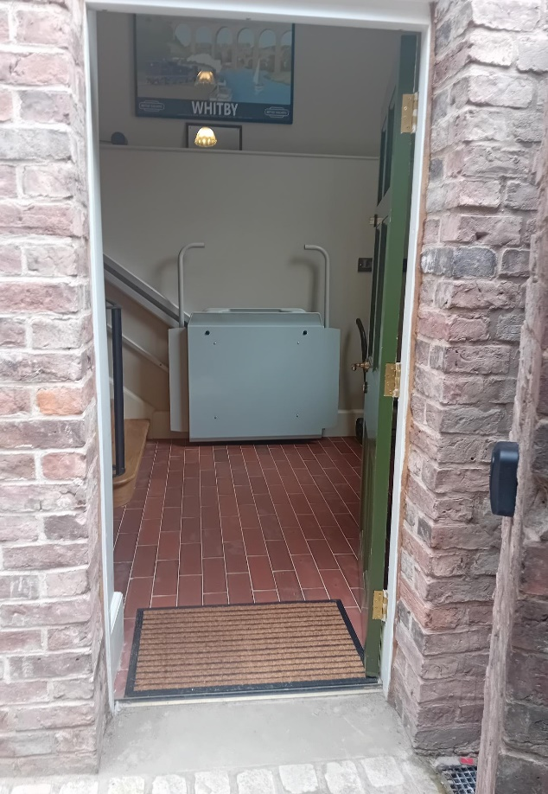

Image 2: The entrance doorway, looking into the cloakroom and including key safe and platform lift

# Getting around inside

### The entrance cloakroom leads to a central hallway. The door into the hallway is 840mm wide; the hallway is 1030mm wide at its narrowest.

From the hallway, there are two accessible bedrooms and a corridor with one accessible shower room and the passenger lift.

Lighting throughout the main circulation areas is controlled by sensor and will stay on for 10 minutes once activated.

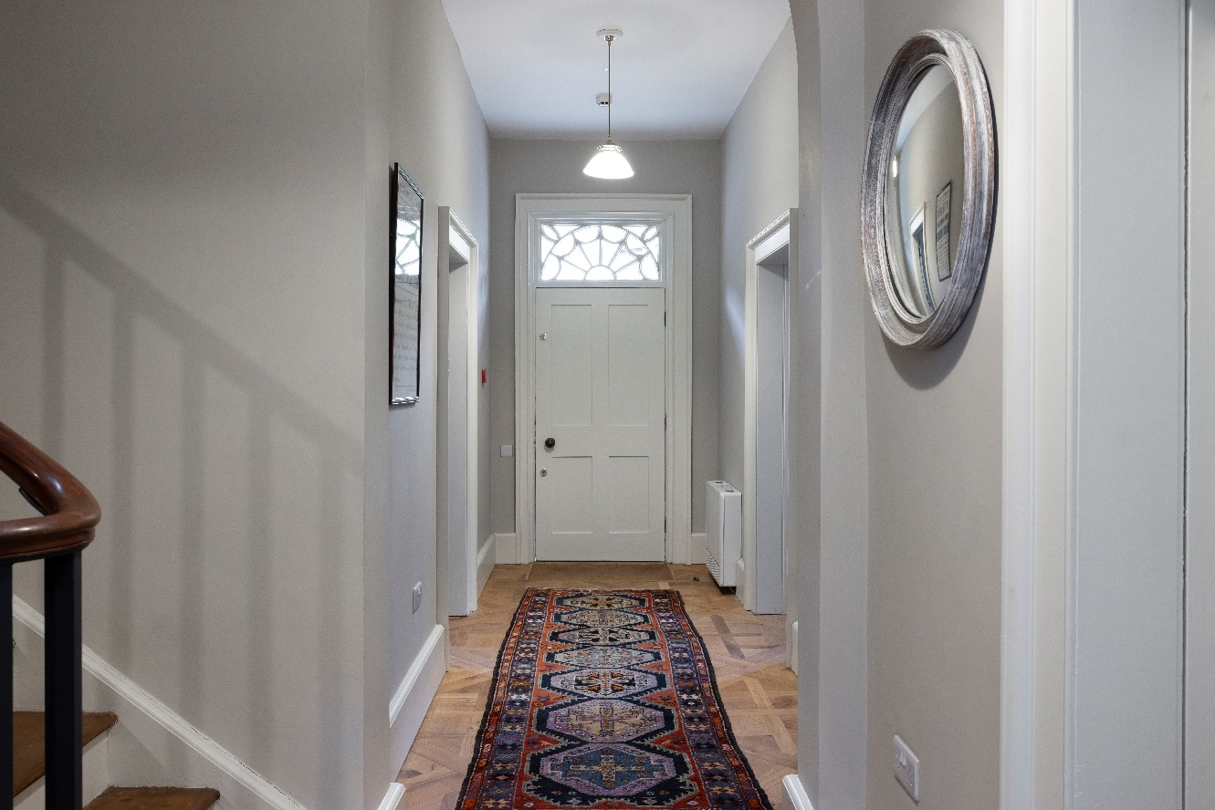

Image 4: The ground-floor hallway, looking towards the bedrooms

### Accessible bedrooms



* One bedroom has a double bed; the second bedroom has twin beds.
* We have non-allergic bedding.
* We provide two additional hypo-allergenic pillows, stored in the bottom of the wardrobe in the twin bedroom.
* The walls and the bedroom fittings have high colour contrast.
* We can move the bedroom furniture to improve accessibility.

Double bedroom

* The bedroom door is 830mm wide.
* There is a threshold slope of 25mm into the room.
* Around the bed is unobstructed space: 1150mm to its left-hand side and 1240mm to its right-hand side.
* The height of the bed is 600mm. There is no clearance under the bed.
* There is furniture for hanging clothes, including at a height of 1330mm from the floor. There is a low towel rail.
* There is a central ceiling light, controlled by a switch inside the doorway and a switch positioned on the right-hand side of the bed. There are lamps on both sides of the bed.

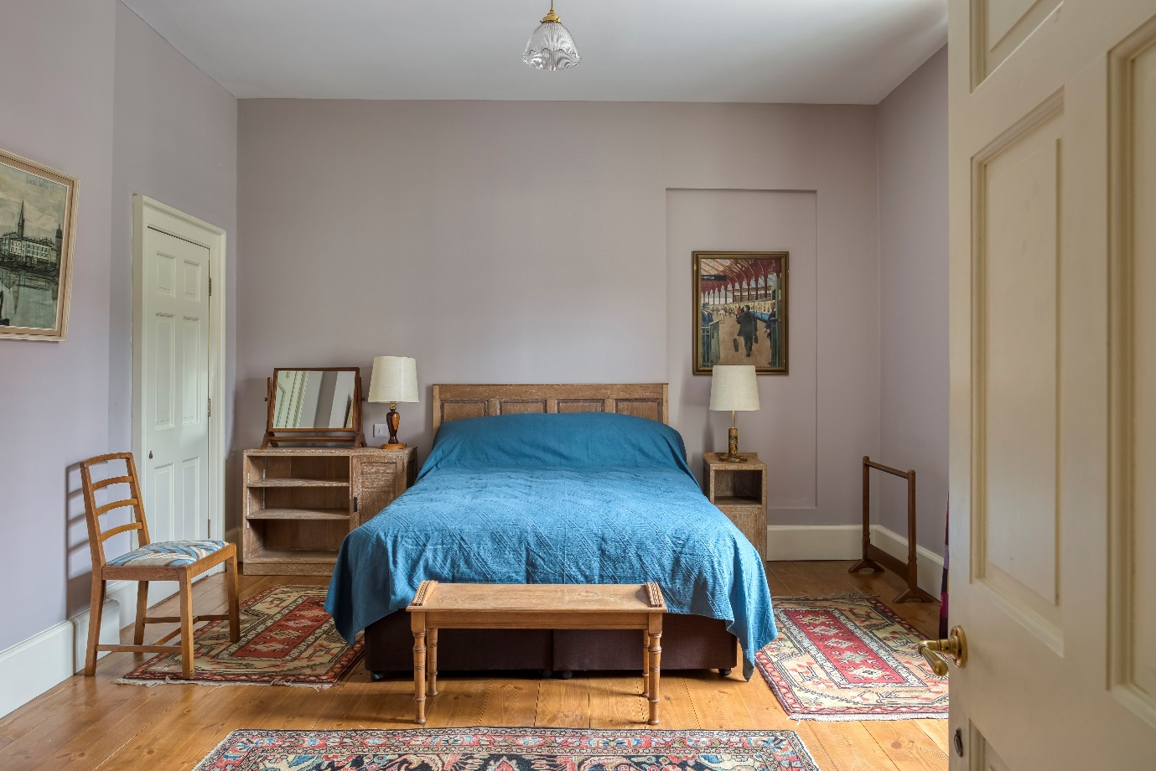

Image 5: Double bedroom

Twin bedroom

* The bedroom door is 830mm wide.
* There is a threshold slope of 25mm into the room.
* There are two single beds. The width to the left-hand side of one bed is 940mm; the width to the right-hand side of the other is 1940mm.
* The height of both beds is 600mm. There is a 200mm clearance under both beds. The gap between beds is 25mm.
* There is furniture for hanging clothes, including a low towel rail.
* There is a central ceiling light, controlled by a switch inside the doorway and a switch positioned by the left-hand bed. There are lamps by both beds.

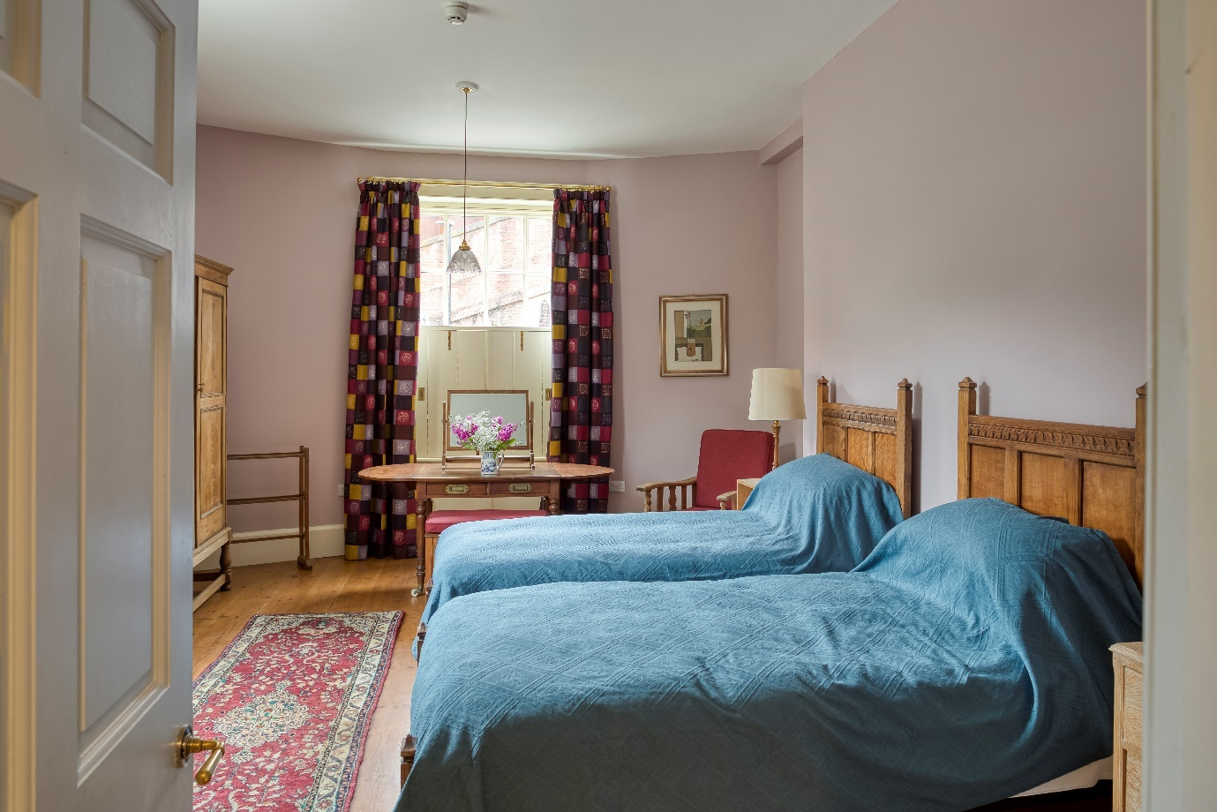

Image 6: Twin bedroom

From the central hallway, a corridor leads past a staircase and to the accessible shower room and passenger lift which provides access to the first floor.

The corridor is 870mm wide at its narrowest.

**Accessible shower room**

* The doorway into the shower room is 840mm wide.
* The height of the toilet is 520mm. It has handrails and the direction of transfer is to the left; there is 830mm at the side of the toilet.
* The height of the basin is 810mm and there is space underneath. The taps are lever operated.
* The shower is a level access shower. The width of the shower is 770mm. There are handrails and a folding seat.
* The light is controlled by a switch outside the door.
* The walls and the bathroom fittings have high colour contrast.

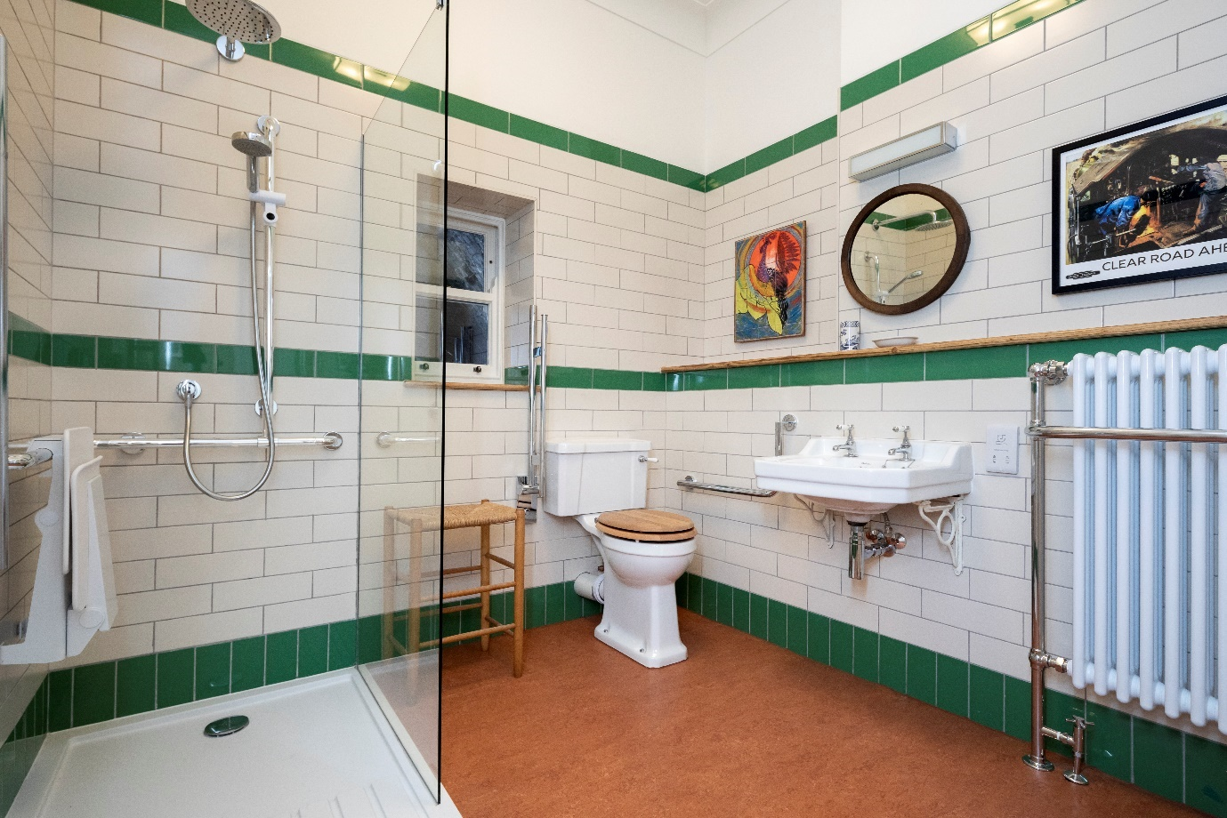

Image 7: Accessible shower room, with fittings

**Passenger lift**

* The passenger lift is located behind a wooden screen which will be positioned open.
* The passenger lift door is side hung and manual.
* The maximum load is 500kg, maximum occupancy six persons.
* To call the lift, press the large up arrow at the entrance to the lift. When you hear an audible click, open the door and enter.
* Once inside the lift, the door will need to be fully closed and the red emergency button fully out to operate. Press and hold the button to travel between floors.
* When the lift comes to a stop, release the button and wait for the audible click, then open the door to exit.

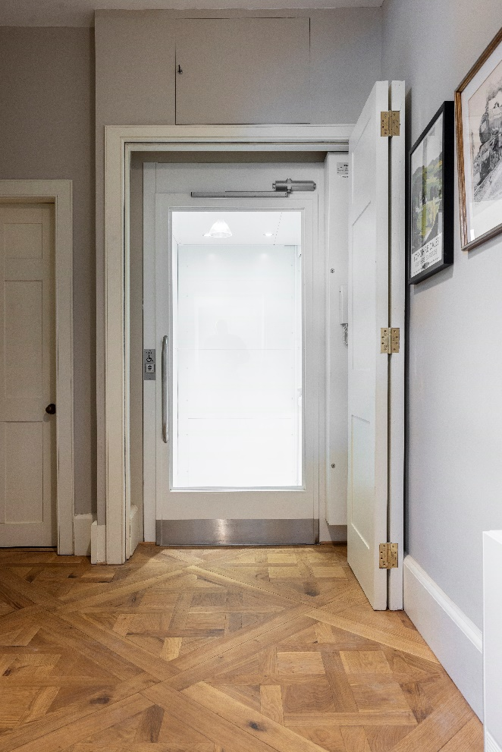

Image 8: Passenger lift

On the first floor, there is level access to an open-plan kitchen, dining and sitting space, plus an accessible toilet and the study.

The first-floor corridor is 850mm wide at its narrowest.

** Sitting room with two triple sofas and two arm chairs facing a fire with a wooden floor Living space**



* The doorway into the kitchen, dining and sitting space is 820mm wide.
* The entrance doorway has a minimal threshold strip for transition between floor finishes.
* There are ceiling lights, controlled by a switch inside the doorway. In addition, the sitting space features lamps and the kitchen features lighting above the worktop, controlled by switches adjacent to the worktop.

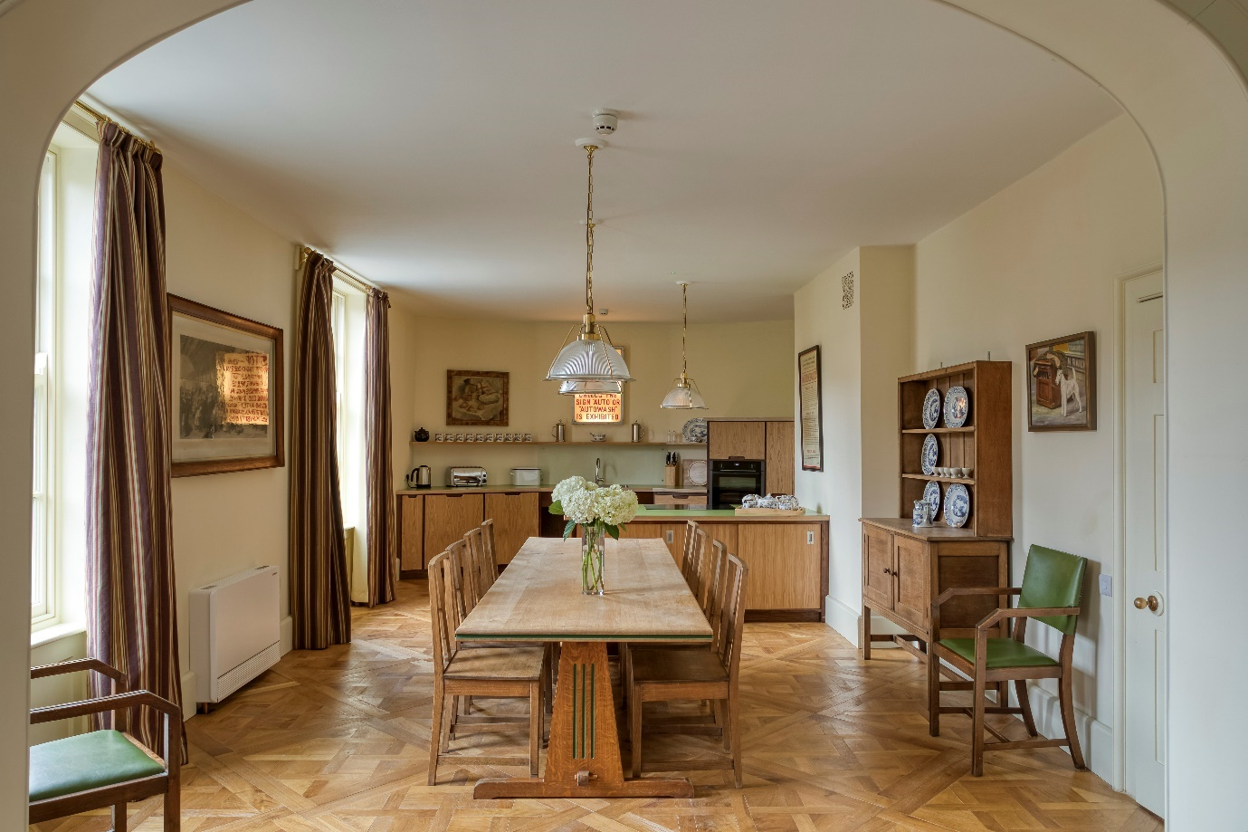

Image 9: The living space, looking towards dining and kitchen facilities

Image 10: The living space, looking towards the sitting facilities

Kitchen facilities

* The self-catering kitchen includes worktops with a height of 910mm from the floor.
* Situated centrally in the worktop, the kitchen sink has clear under space at a height of 690mm.
* The hobs are positioned in an island unit, with a height of 850mm and clear under space at a height of 750mm. The hobs have touch control.
* There are two ovens, each featuring sliding doors. The principal oven is positioned at a height of 710mm; beneath the oven is a sliding heat-resistant surface for hot ovenware as they go into/out of the oven.
* Next to the principal oven is a pull-out worksurface. There is a socket immediately adjacent to the work surface.
* A microwave is positioned inside a cupboard at a height of 1280mm.
* All crockery, glassware and cooking equipment is stored in low-level cupboards. Cupboards have sliding doors or spring-fitted hinges.

|  |  |
| --- | --- |
| A kitchen with laminate-wood units. The worktops are pale green and the cupboard doors a pale wood colour. In the foreground, an island unit features a touch-control hob. In the background are a sink, cupboards and an oven. On the worktop is a kettle, toaster and bread bin. Above the sink is a shelf displaying crockery. | An oven with its sliding door open. Beneath the oven is a pull-out heat resistant board. |
| Image 11: The kitchen | Image 12: The principal oven and pull-out heat-resistant board. |

Dining facilities

* The large dining table has a height of 740mm, with space underneath to a height of 695mm.
* The dining table is presented with eight chairs without arms. Two additional armed chairs are positioned nearby. All chairs can be moved around for flexibility.

**Accessible toilet**



* The doorway into the accessible toilet room is 840mm wide.
* The height of the toilet is 520mm. It has handrails and the direction of transfer is to the right; there is 840mm at the side of the toilet.
* The height of the basin is 810mm and there is space underneath. The taps are lever operated.

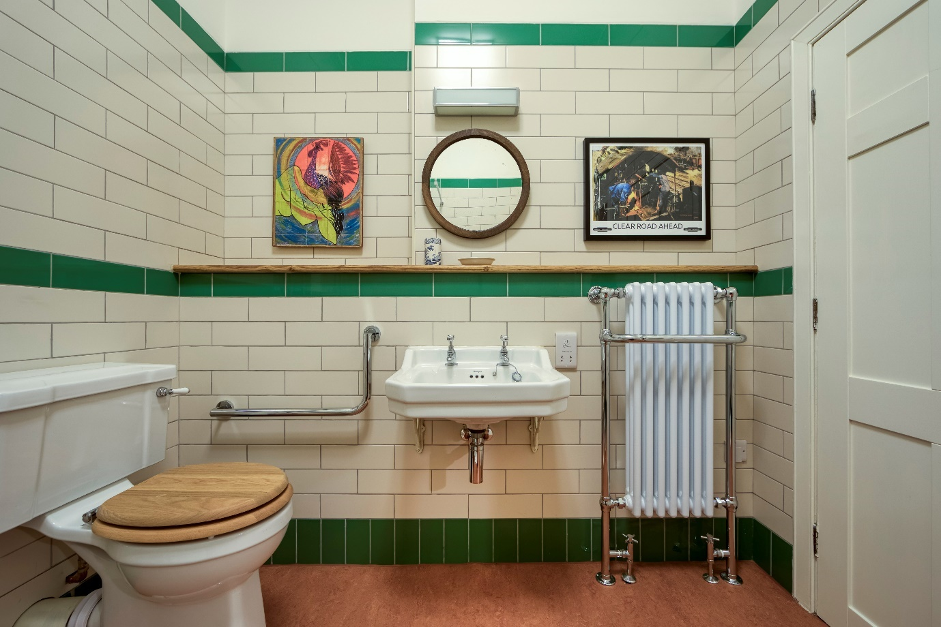

Image 13: The accessible toilet

# Customer care support

### Emergency evacuation procedures

* The fire and CO2 alarms have both audible and flashing visual alarms if they go off.
* The passenger lift is fitted with a red emergency button which will stop the lift and a button to emit a siren in the case of a malfunction or emergency. There is a handset situated next to each lift entrance and one inside to communicate with anyone inside. When the handset in the lift is removed from the cradle it will automatically dial the phone outside.